**Assignment 1 Java**

1.

• Java was initially developed for consumer electronics but later adapted for web development.

•It's a platform-independent language, meaning it can run on different operating systems.

•Java is known for its object-oriented programming paradigm, which helps create modular and reusable code.

• It's widely used for building web applications, Android apps, and server-side software.

• Sun Microsystems (now owned by Oracle) is the primary company behind Java.

•Java's popularity is due to its reliability, security, and ease of use.

2.

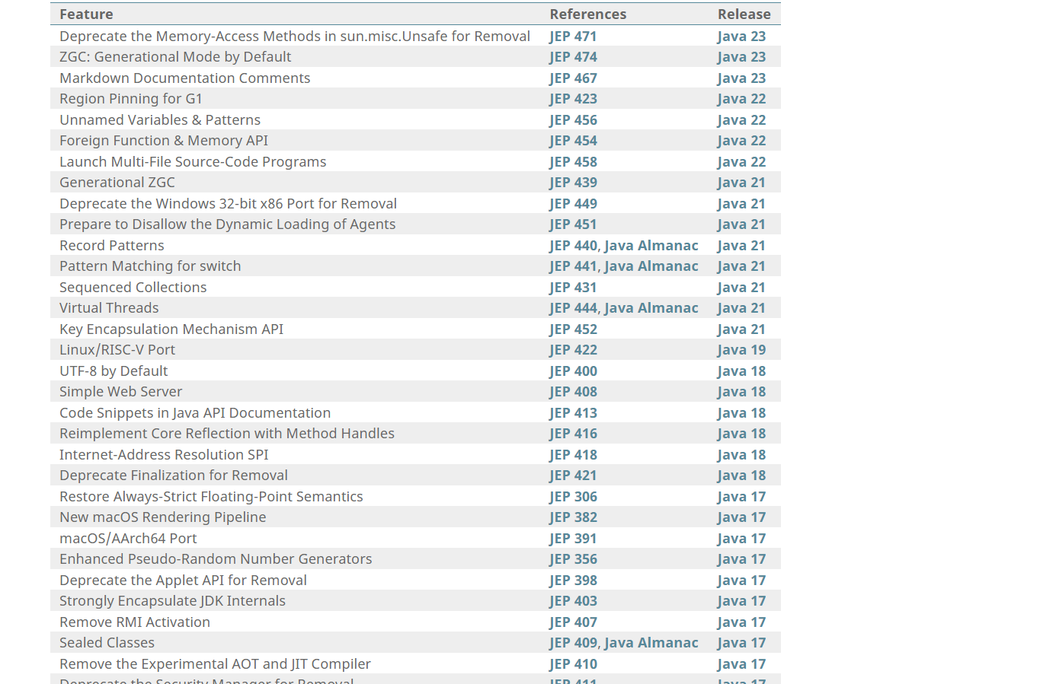

3.

According to the class requirement I am going to use java 8 or above version

Currently in my windows 11 system I have installed java 21

4.

* **bin**: This folder stores executable files for all the development tools you'll need, like javac (Java compiler) and java (Java runtime).
* **lib**: This folder contains essential files used by the development tools, including core libraries like tools.jar and dt.jar.
* **jre**: This directory holds the Java Runtime Environment (JRE) that's used by the JDK development tools. JRE is what allows you to run Java programs.
* **src.zip**: This archive contains the source code for the Java platform, useful for advanced users who want to delve into the inner workings of Java.
* **include**: This folder stores C-language header files that provide support for native code programming with various libraries. These are helpful for situations where you need to interact with code written in C or C++.

5.

**Important points about Java technology and its components:**

* **Java as a Programming Language:**
  + High-level, simple, object-oriented
  + Designed for distributed applications
  + Supports multithreading for concurrent execution
  + Secure and robust
* **Java as a Platform:**
  + Software-only platform, runs on top of existing hardware platforms
  + Two main components:
    - Java Virtual Machine (JVM): Executes bytecode instructions, provides platform independence.
    - Java Application Programming Interface (API): Provides pre-written software components for various functionalities.

7.

* The JVM is a program that executes bytecode instructions, providing platform independence for Java applications.
* It has three main subsystems:
  + Class Loader: Loads, links, and initializes class files.
  + Runtime Data Area: Stores data for the JVM, including:
    - Method Area: Holds loaded class information.
    - Heap Area: Stores object instances during program execution.
    - Stack Area: Manages method calls and local variables.
    - PC Registers: Keep track of the program counter (instruction pointer).
  + Execution Engine: Executes bytecode instructions by interpreting them or compiling them to native code for the underlying operating system.

8.

**Java is object-oriented:** Programs are built around objects that encapsulate data and behaviour.

**Architecture neutral:** Java code can run on any platform that has a Java Virtual Machine (JVM).

**Portable:** Once written, Java code can run on any system with a JVM.

**Robust:** Java has features that help prevent errors and crashes.

**Interpreted:** Java bytecode is translated into machine code at runtime by the JVM.

**Dynamic:** Java programs can load and execute code at runtime.

6.

